**Task 10**

1. Difference between chmod and chown?

Syntax :

|  |  |
| --- | --- |
| **chmod** | **chown** |
| Used to change the permissions of a file or directory | Used to change the ownership of a file or directory |
| It sets who can read, write, or execute a file | It changes the user and/or group that owns a file |
| Modifies who can read, write, or execute the file (user, group, others) | Changes the owner and/or group of the file. |

1. How do you list all users on a system?

Syntax : **cat /etc/passwd**

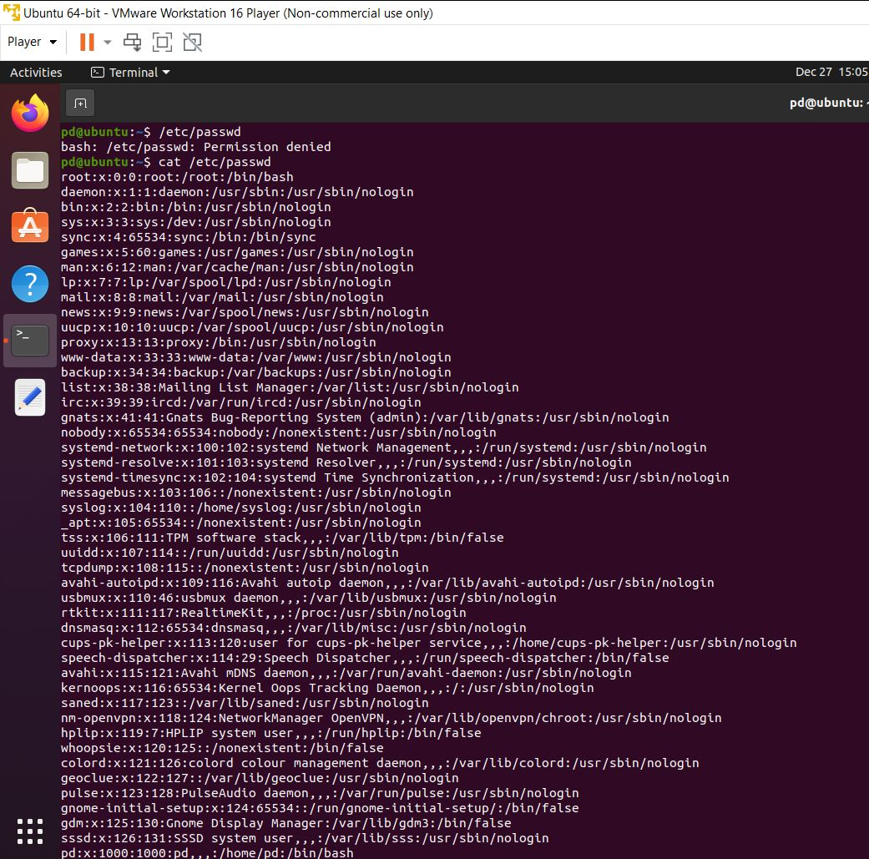

1. How do you change the ownership of a file?

Syntax: **sudo chown <username> <filename>** 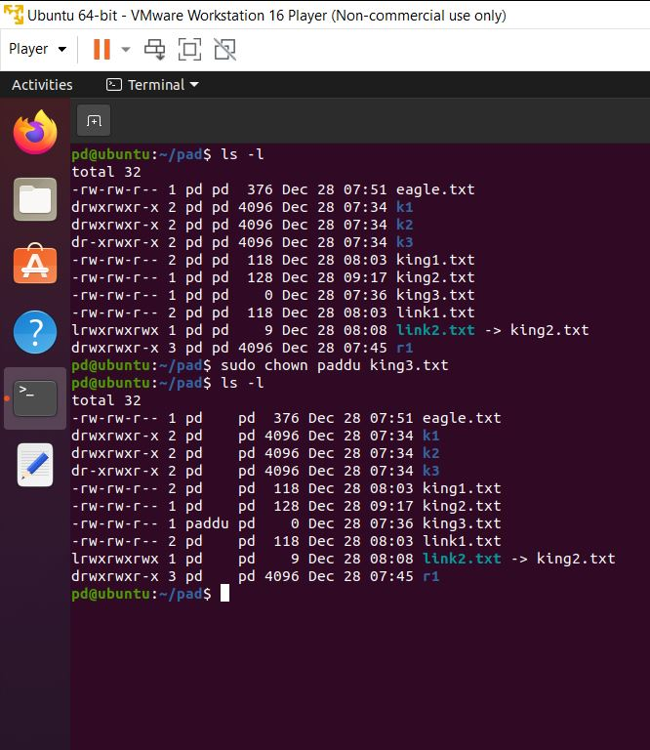

1. How to check the permission of a file?

Syntax: ls –l <file name>

This command displays detailed information of a file

-rw-rw-r-- 1 pd pd 307 Dec 28 12:16 eagle.txt

• - = regular file

• d = directory

• l = symbolic link

|  |  |  |  |  |  |  |  |  |  |  |  |  |  |  |  |
| --- | --- | --- | --- | --- | --- | --- | --- | --- | --- | --- | --- | --- | --- | --- | --- |
| user | | | group | | | other | | | UN | GP | SIZE | MONTH | DATE | TIME | FILE NAME |
| r | w | x | r | w | x | r | w | x | USER NAME | GROUP NAME | SIZE OF FILE IN BYTES | TIME AND DATE OF LAST MODIFIED | | | FILENAME |
| read | write | execute | read | write | execute | read | write | execute |

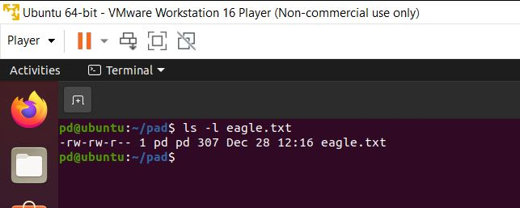

1. How to recover a user’s password if they’ve forgotten it, assuming you have root access?

Syntax: **sudo passwd <user name>**